Objective: Lab 6 is to Create a bare-metal “Hello World” application and run it on a debug configuration for a Cortex-A9 Fixed Virtual Platform (FVP) provided with ARM Development Studio.
Document I followed to install the necessary things: document to install arm ds and others eds tolls
Procedure:
- Install SoC EDS
- Install ARM DS
- Install Cygwin
- Install MingGW
- Install Linaro Bare Metal Toolchain
- Installing tools on Windows.
- Running the tools and activating the license
- After activating the arm ds tool kit licensing ,Create your c project
Steps to create a c project
- Select File > New > Project to display the C Project dialog
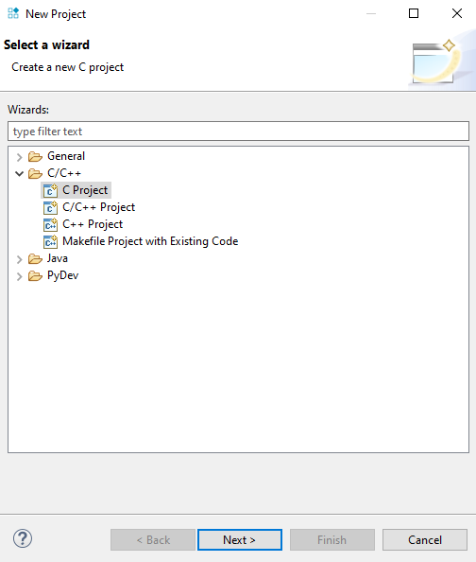

- In Project name field, enter the name of your project.
- Under Project type, select Empty Project.
- Under Toolchains, select Arm Compiler 6.
- Click Finish to create a C project.
- You can view the project in the Project Explorer view
- Create the source folder and source file named .c and write c program which print “Hello world”

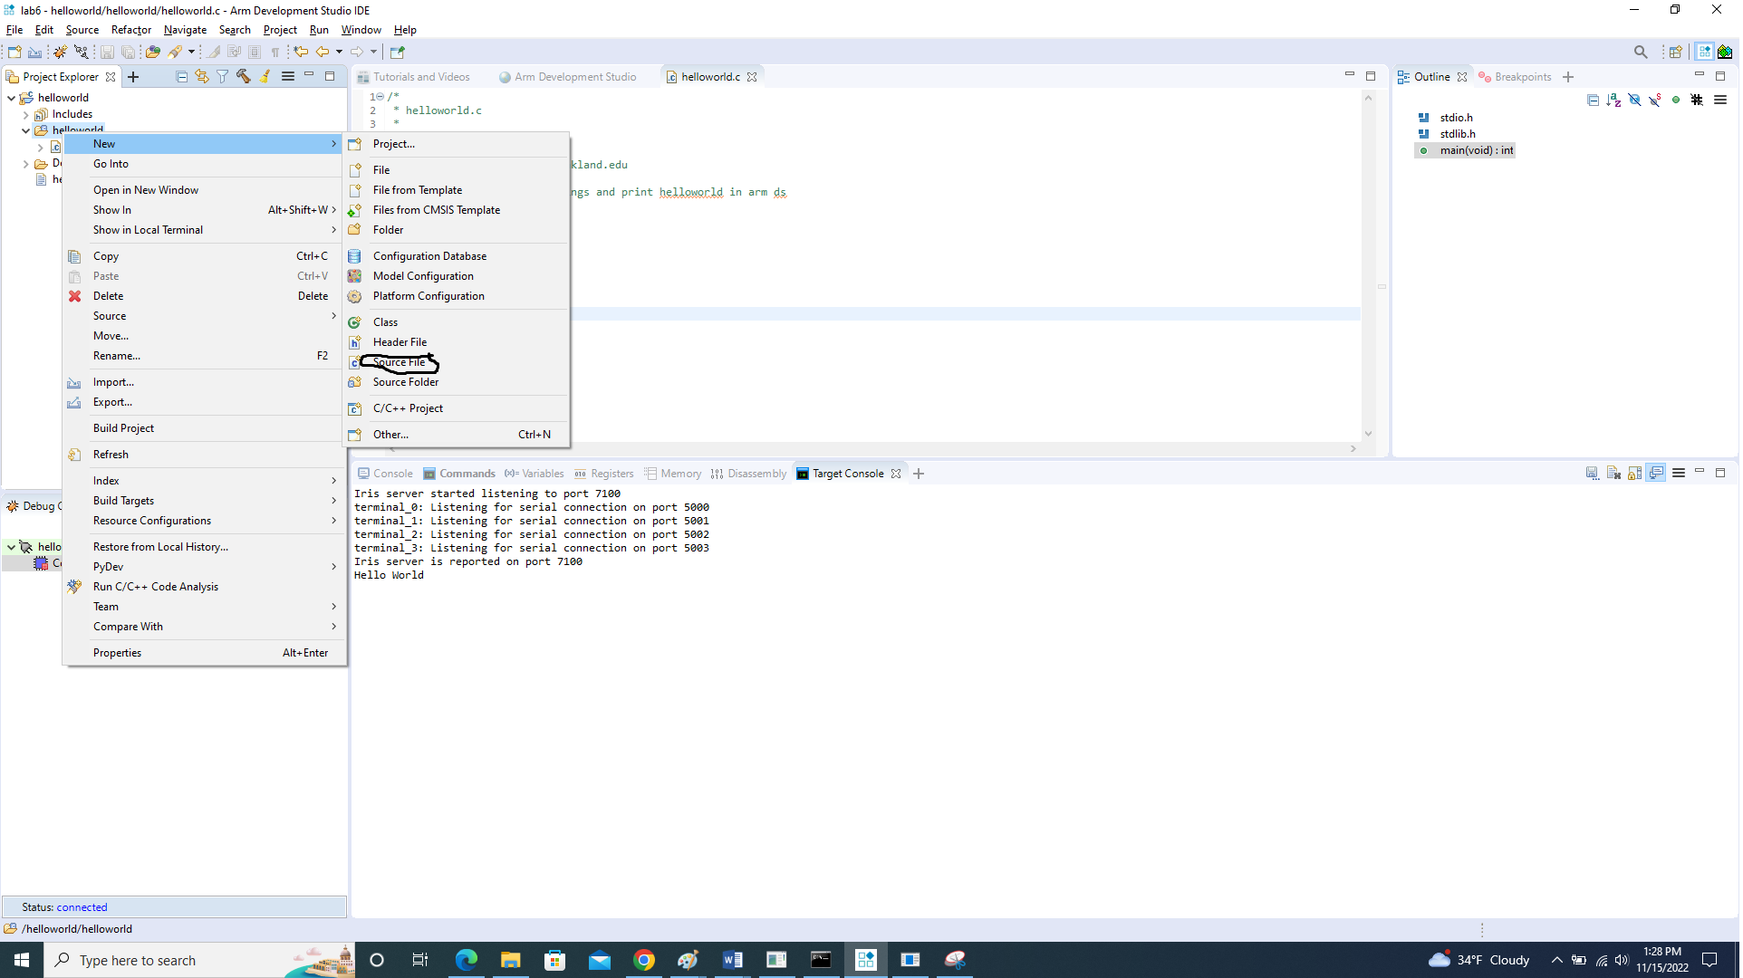

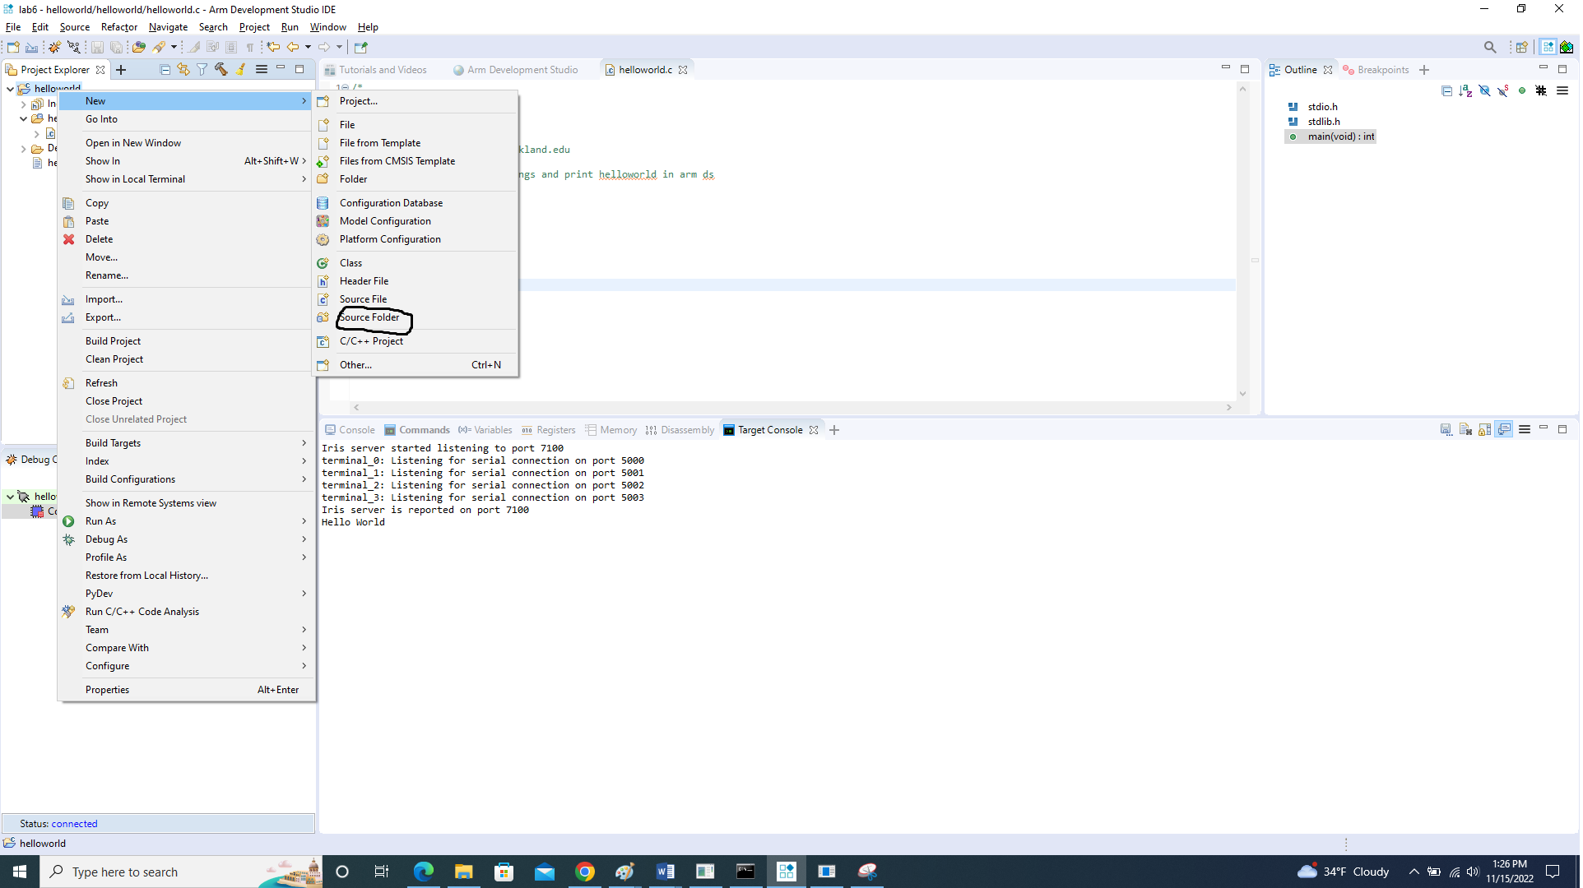

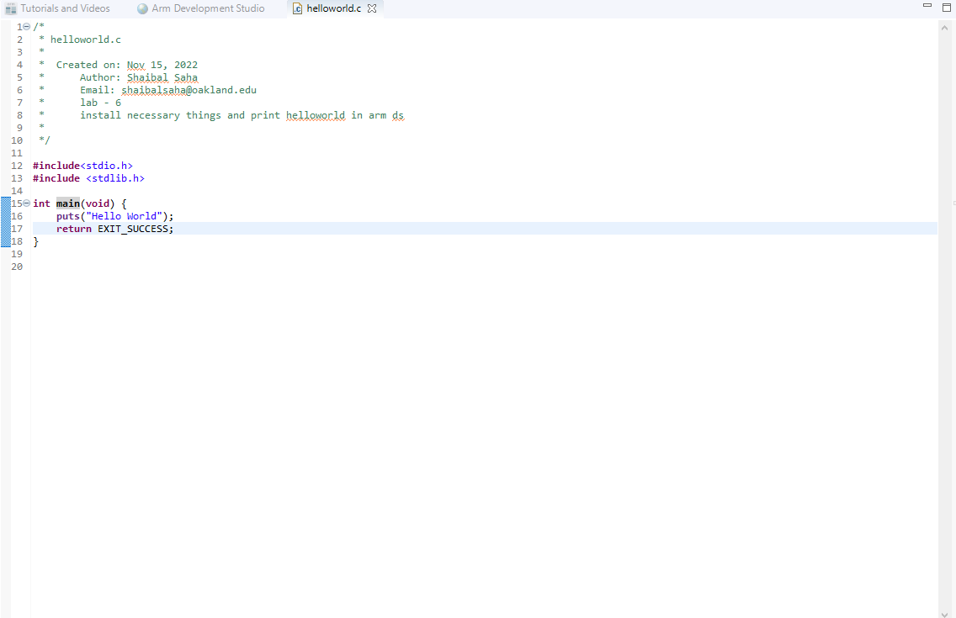
- After writing the project ->In Project Explorer, right-click on the project and select Properties
- In the Properties dialog:
  - Browse to C/C++ Build > Settings.
  - Under the Tool Settings tab, browse to All Tools Settings > Target, and from the Target CPU drop down select Cortex-A9.
  - Under the Tool Settings tab, browse to All Tools Settings > Target, and from the Target FPU drop down select No FPU.
  - Under the Tool Settings tab, browse to Arm Linker 6 > Image Layout.
  - In the RO base address (--ro_base) field, enter 0x80000000
  - Click apply and screenshots are below.

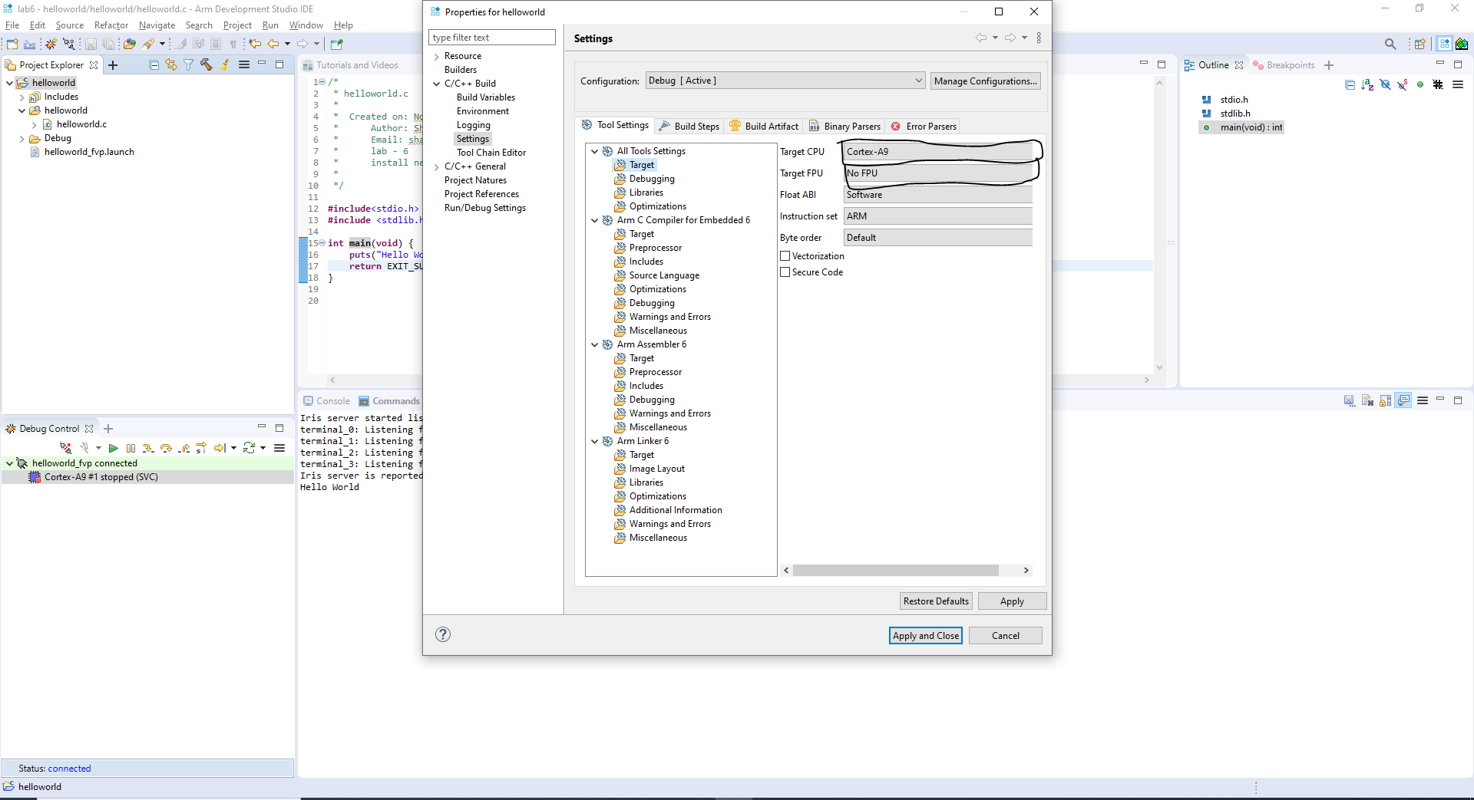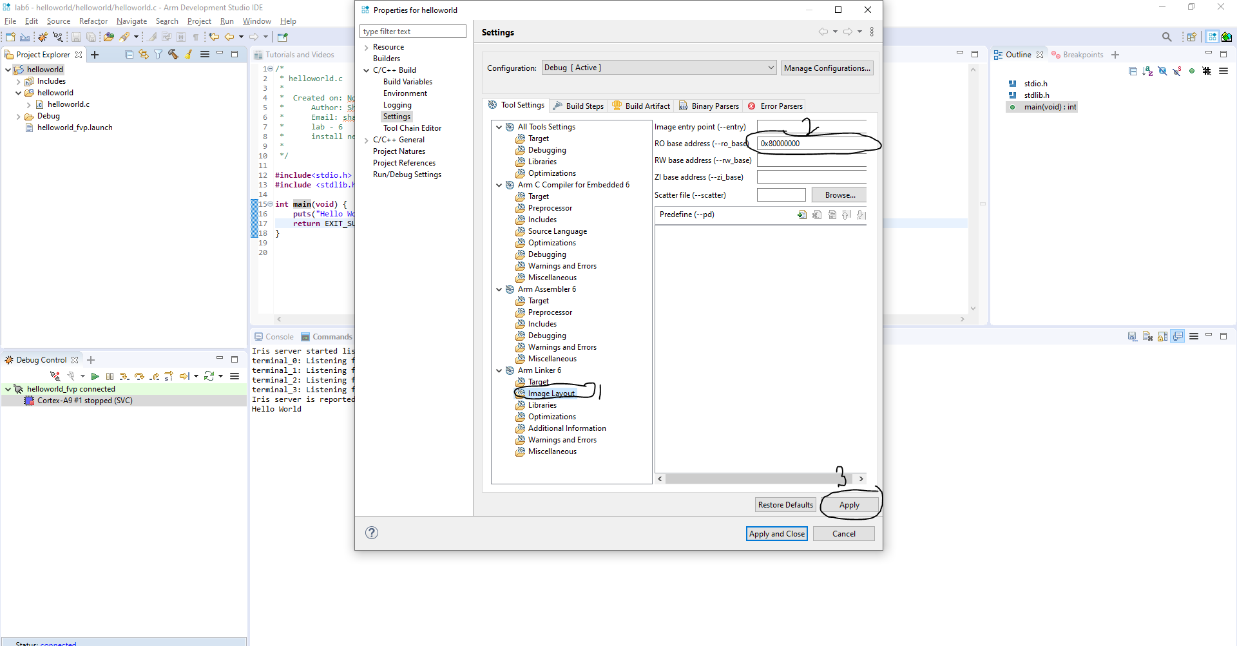
- Now build the project which will create your .axf file which I need later for FVP configuration.
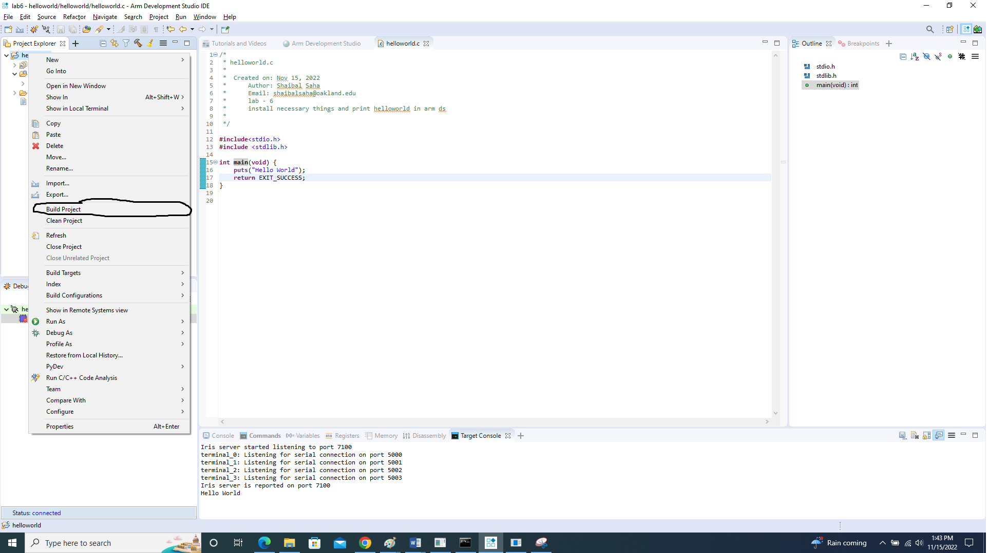
- For debug model connection create
  - Click the + sign in debug control window in the lower left side in the arm ds.
  - In the Connection tab, under Select Target, browse and select Arm FVP (Installed with Arm DS) > VE_Cortex_A9x1 -> Finish.
  - Select the Files tab, and under Target Configuration in the Application on host to download field, click Workspace.
  - The Workspace contains the HelloWorld.axf application file that created when built the Hello World project.
  - Select the Debugger tab, and ensure the Debug from symbol option is selected and set to main.
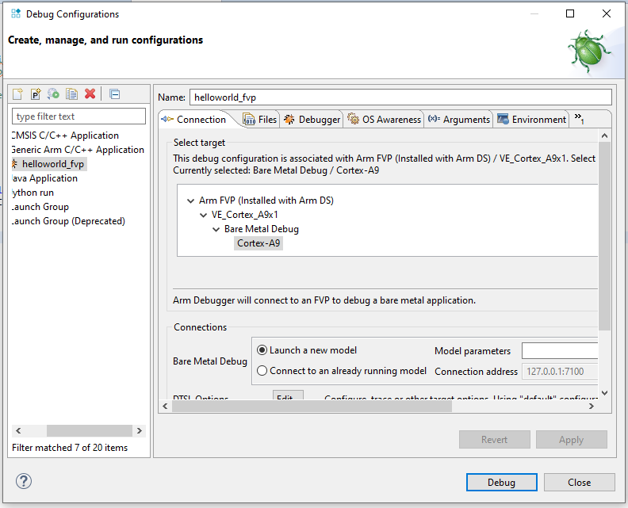
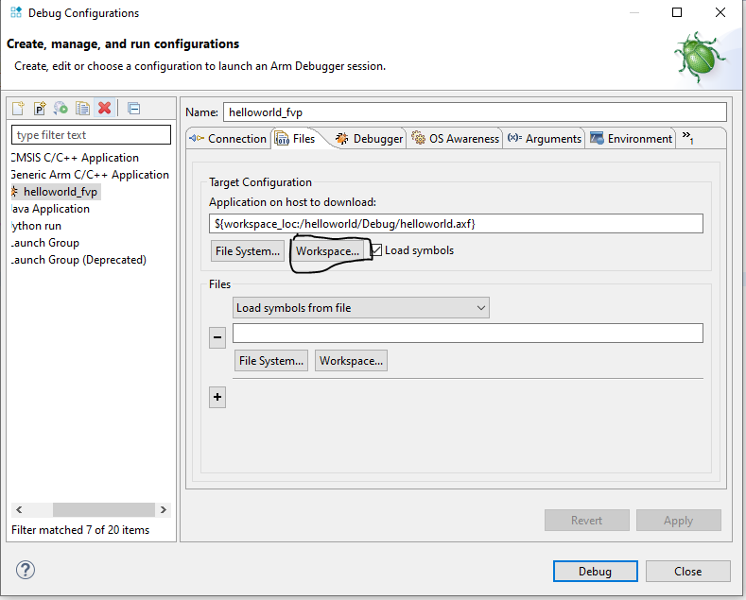
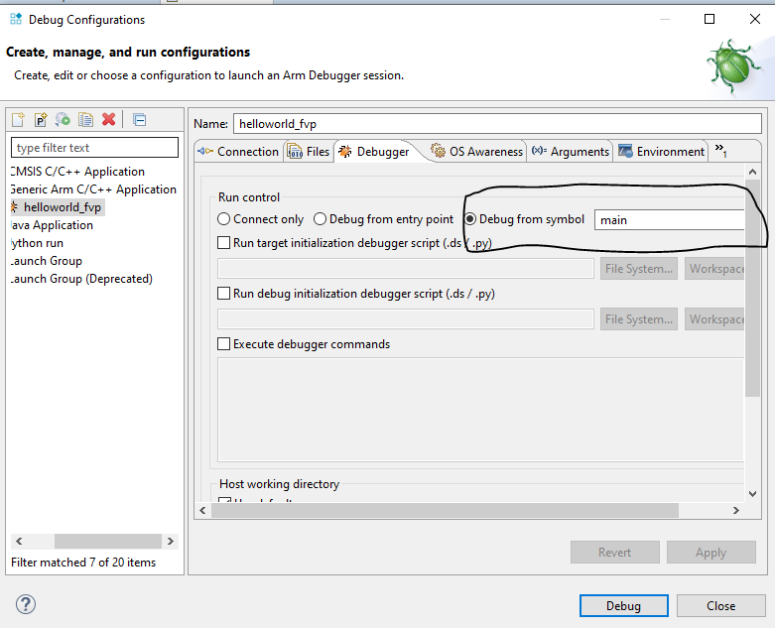
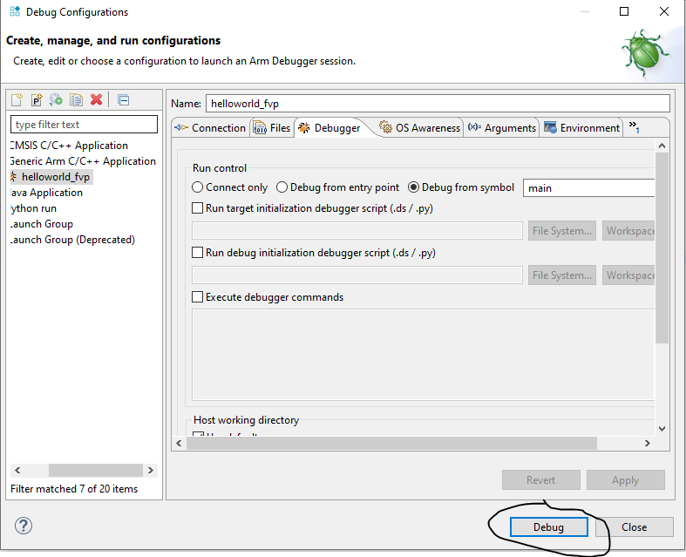
- After click debug, it will connect to the model and displays the connection status in the Debug Control.

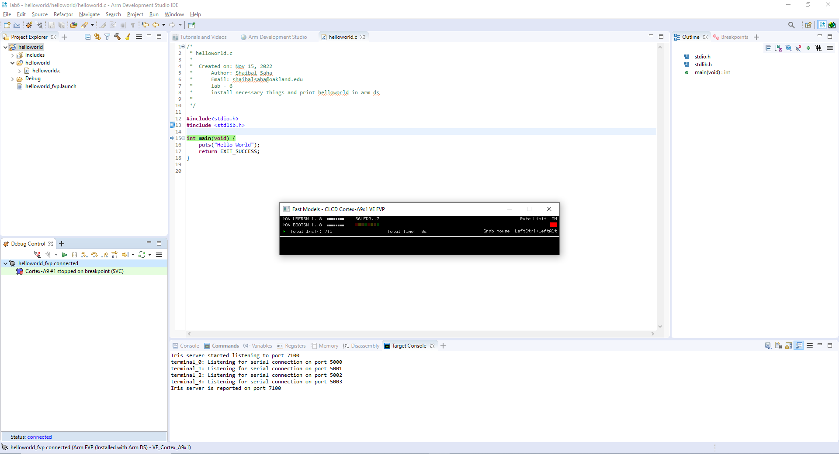
- Run the FVP

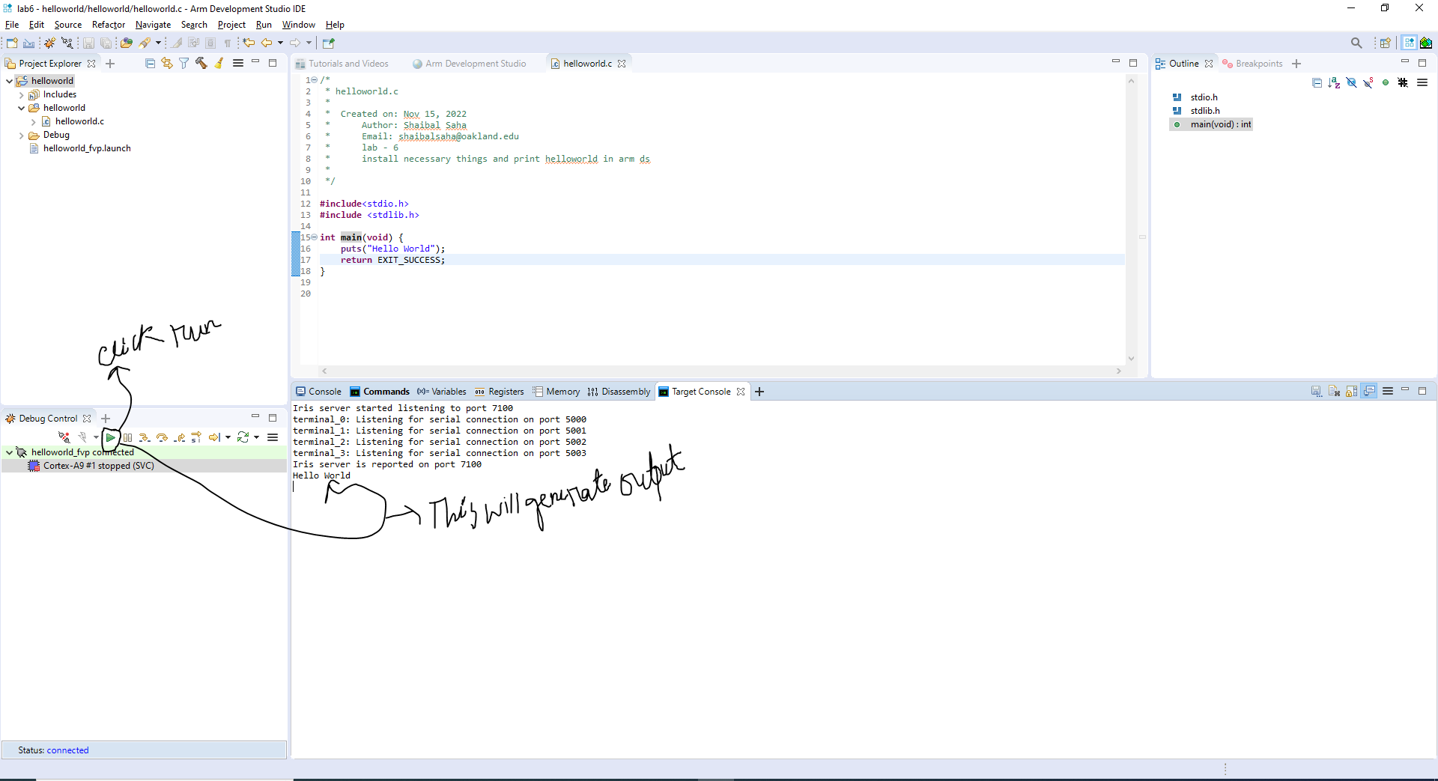

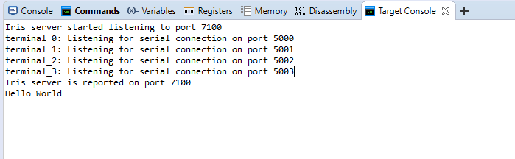
- So, it will show the output in the target console. We can also see the disassembly view that the loaded program in memory as assembler instructions at addresses.

NOTE: Source files are inside the lab6/helloworld folder

